Activity No 5 .Finance Club Event “Fiscal Riddlers”

Title of the Event | Finance Club Event “Fiscal Riddlers” | 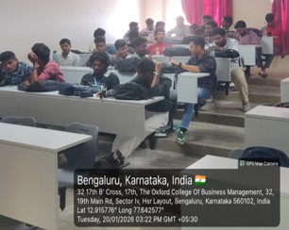
Day and Date | 20.01.26
Venue (With all details ) | Roon No-309
In collaboration with ( if any) | -
Details of Resource Person With Designation | Asst.Prof. Ritu U | 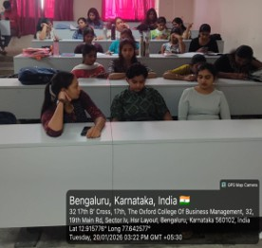
Organizing Department/Coordinators | Business Management . Asst.Prof. Ritu U
Course and semester | MBA I Semester
No of Students & Faculty Participants | 42

Coordinator HoD Vice-Principal Principal

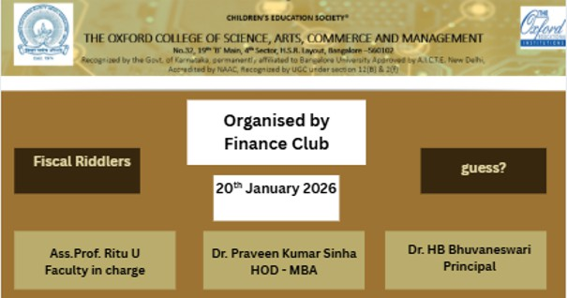

Introduction
On January 20, 2026, the Finance Club organized a unique and intellectually stimulating event titled "Fiscal Riddlers," focusing on financial riddles. The primary goal of this session was to move beyond traditional textbook definitions and challenge students to apply lateral thinking to financial concepts. By framing complex economic principles as puzzles, the activity aimed to improve cognitive recall and make the subject matter more approachable and entertaining for participants of all levels.

Description of the Activity
The activity was structured as a multi-round riddle challenge where students were presented with cryptic clues describing financial instruments, market trends, or monetary concepts. Participants had to decode the descriptions using their knowledge of the financial world. The riddles covered a broad spectrum of topics, including personal finance (e.g., credit scores and interest), corporate finance (e.g., dividends and mergers), and market dynamics (e.g., "Bull" vs. "Bear" markets). To increase the competitive spirit, students were divided into teams, and each riddle was timed to encourage quick thinking and collaborative brainstorming.

Outcome of the Activity

The session yielded highly positive results, with students demonstrating an impressive ability to connect abstract clues to concrete financial terms. Key outcomes included: Enhanced Analytical Skills: Students moved past rote learning to understand the "logic" behind how finance works.High Participation Levels: The riddle format kept engagement high, with teams debating answers enthusiastically.Simplified Learning: Intimidating topics like inflation or bankruptcy were broken down into simple, relatable puzzles, making them easier to grasp for newcomers to the club.Team Synergy: The group-based format improved communication and collective problem-solving among club members.

Conclusion
The "Capital Conundrums" riddle event on January 20, 2026, was a resounding success, proving that gamified logic puzzles are an effective pedagogical tool for financial literacy. By the end of the session, students felt more confident in their ability to identify and explain various financial concepts. Based on the positive feedback and the high level of intellectual curiosity sparked by the event, the Finance Club plans to incorporate "Case Study Riddles" in future meetings to further bridge the gap between theory and real-world application.

